Database Tools with ORM stack

Contents

1. Introduction 3
2. Workflow diagram to deploy the stack 3
3. Create stack for Database Tools 4
4. Plan the Job 7

Introduction

Database connections are resources that contain the necessary information for accessing an Oracle Database in OCI. Connections are created by simply providing information about where the database is and what type it is (Autonomous, VM, or Exadata). The connection also contains the user used to access the database as well as the location of the password that is stored in the OCI vault.

Workflow diagram to deploy the stack

Below diagram shows how the Terraform Artifact are applied in the OCI. While creating a ORM stack, using terraform deliverables Init, Plan and Apply is the flow to provision the resource in the OCI. We can have the deliverables in any of below.

- GitLab/GitHub Repo
- Bitbucket
- Can be in folder/.zip in the local disk
- Object Storage Bucket
- Can be in compartment
- Oracle provided Template


Create stack for Database Tools

Go to OCI Console Developer Services Resource Manager Stacks select the compartment Create Stack

My Configuration Folder Browse Select the “Database_Tools” folder that contains the terraform Upload

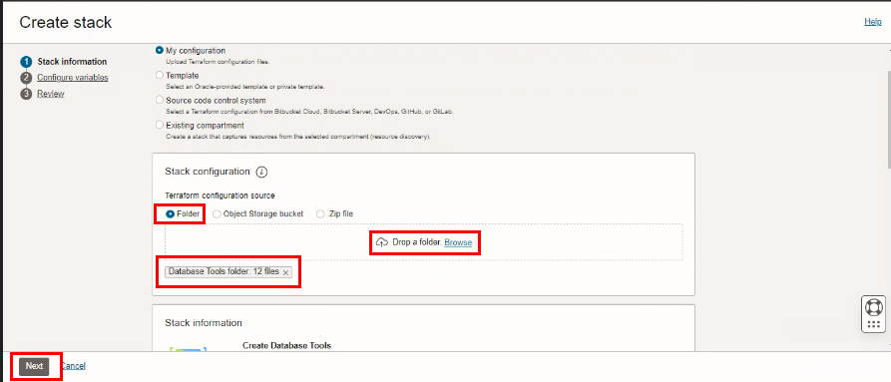

Select the parameters as per the below screen,

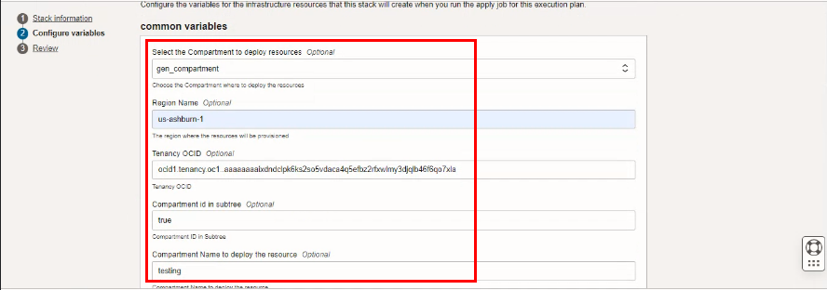

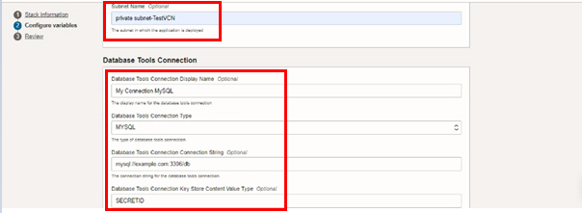

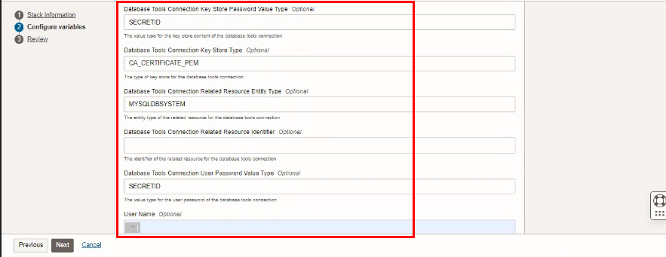

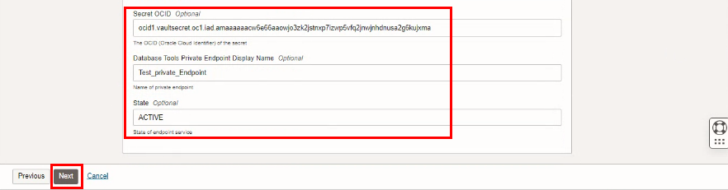
Click “NEXT”

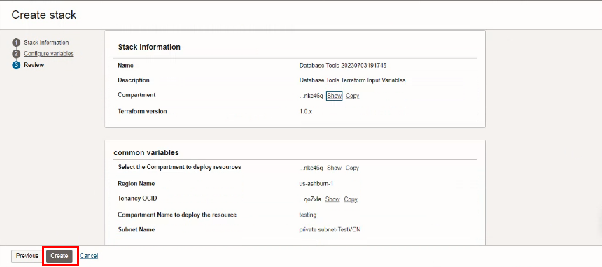
Click “CREATE”

Plan the Job

Click the “Plan”
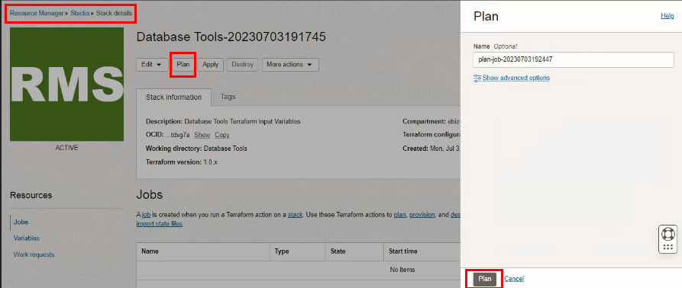

Verify the Plan is successful.

